Magnetism - 03
CLASS 10 - SCIENCE

 | Section A
1 | Find the incorrect statement  - Field lines emerge from the south pole and merge at north pole.  - Magnetic field lines can intersect each other.  - A wire with a red insulation is usually the neutral wire of an electric supply.  - All of these  a) D  b) C  c) A  d) B | [1]
2 | For a current in a long straight solenoid, N and S poles are created at the two ends. Among the following statements, the incorrect statement is:  - The magnetic field lines inside the solenoid are in the form of straight lines, which indicates that the magnetic field is uniform at all points inside the solenoid.  - The strong magnetic field produced inside the solenoid can magnetize the soft iron placed inside it.  - The pattern of the magnetic field associated with a current carrying solenoid is different from the pattern of the magnetic field around a bar magnet.  - The N and S poles exchange positions when the direction of current through the solenoid is reversed.  a) Statement (c) is incorrect.  b) Statement (d) is incorrect.  c) Statement (b) is incorrect.  d) Statement (a) is incorrect. | [1]
3 | Choose the incorrect statement from the following regarding magnetic lines of field  a) The direction of the magnetic field at a point is taken to be the direction in which the north pole of a magnetic compass needle points  b) If magnetic field lines are parallel and equidistant, they represent zero - field strength  c) Magnetic field lines are closed curves  d) The relative strength of the magnetic field is shown by the degree of closeness of the field lines | [1]
4 | Which one of the following is correct -  - Fuse wire is an alloy of tin and lead  - Switch is always connected to live wire  - Alternate current is unidirectional  - Higher is the value of current flow, weaker is the magnetic field  a) B and C  b) A and C  c) A and B  d) A, B, C and D | [1]
5 | Which of the following sentences is correct about Overloading?  a) Overloading can occur when the live wire and the neutral wire come into direct contact.  b) Overloading is caused by connecting too many appliances to a single socket.  c) Overloading can occur due to an accidental hike in the supply voltage.  d) All of these | [1]
6 | Which of following statement is not correct about electric fuseA. It is always connected in live wire B. It is always connected in the end of the circuit C. Thinner the fuse wire, greater is its current capacity D. Its current capacity must be less than the maximum current  a) B and C  b) A and B  c) A and C  d) A, B, C and D | [1]
7 | Choose the incorrect statement  a) The difference between the direct and alternating currents is that the direct current always flows in one direction, whereas the alternating current reverses its direction periodically  b) Fleming’s right - hand rule is a simple rule to know the direction of induced current  c) The right - hand thumb rule is used to find the direction of magnetic fields due to current carrying conductors  d) In India, the AC changes direction after every$\frac{1}{50}$ second | [1]
8 | Pick out the incorrect statement about magnetic lines of force.  a) Magnetic lines of force are far away .from each other at the poles.  b) Magnetic lines of force closed continuous curves.  c) No two magnetic lines of force can intersect each other.  d) Magnetic lines of forces start from the North Pole and end on the South Pole. | [1]
9 | For current in a long straight solenoid N - and S - poles are created at the two ends. Among the following statements, the incorrect statement is  a) The pattern of the magnetic field associated with the solenoid is different from the pattern of the magnetic field around a bar magnet  b) The strong magnetic field produced inside the solenoid can be used to magnetize a piece of a magnetic material like soft iron when placed inside the coil  c) The N - and S - poles exchange position when the direction of current through the solenoid is reversed  d) The field lines inside the solenoid are in the form of straight lines which indicates that the magnetic field is the same at all points inside the solenoid | [1]
 | Section B
10 | A region ’A’ has magnetic field lines relatively closer than another region ’B’. Which region has a stronger magnetic field? Give a reason to support your answer. | [1]
11 | What is a solenoid? | [1]
12 | How can it be shown that a magnetic field exists around a wire through which a direct current is passing? | [1]
13 | At what place of the magnet are the magnetic field lines closer? | [1]
14 | Name the two factors that completely define a magnetic field at a point. | [1]
15 | What does the divergence of magnetic field lines near the ends of a current carrying straight solenoid indicate? | [1]
16 | State the direction of magnetic field in thefollowing case. 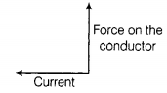 | [1]
17 | What type of core used to make an electromagnet? | [1]
18 | State the observation made by Oersted on the basis of his experiment with current carrying conductors? | [1]
19 | The change in magnetic field lines in a coil is the cause of induced electric current in it. Name the underlying phenomenon. | [1]
20 | Consider a circular loop of thick copper wire lying horizontally on a table. Let the current pass through the loop anticlockwise. Draw the magnetic field lines to show the direction and the pattern of the magnetic field inside and outside the loop. | [1]
21 | An alternating current has frequency of 50 Hz. How many times does it change its direction in one second? | [1]
22 | Mention the shape of the magnetic field lines around a current carrying straight conductor. | [1]
23 | What happens to the magnetic field lines due to a current - carrying conductor when the current is reversed? | [1]
24 | Which of the following circuits will be dangerous even if the fuse blows off and electric iron stops working during a short circuit? 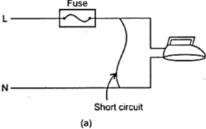  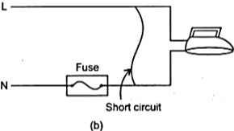 | [1]
25 | How should the electric lamps in a building be connected, so that the switching on or off in a room has no effect on other lamps in the same building? | [1]
26 | Name two safety measures commonly used in electric circuits and appliances. | [1]
27 | Why do two magnetic field lines not intersect each other? | [1]
28 | The diagram given below represents the magnetic field caused by a current carrying conductor. Identify the nature of the coil. 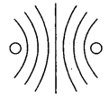 | [1]
29 | What is the shape of a current - carrying conductor whose magnetic field pattern resembles that of a bar magnet? | [1]
30 | The diagram in given figure shows a three pin socket marked as 1, 2 and 3. 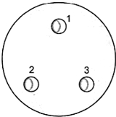  - Identify and write live (L), neutral (N) and earth (E) against the correct number.  - To which part of the appliance is the terminal 1 connected? | [1]
31 | Why is the fuse wire fitted in a porcelain casing? | [1]
32 | Define magnetism. | [1]
33 | How will the direction of force be changed, if the current is reversed in the conductor placed in a magnetic field? | [1]
34 | How can you magnetise a piece of magnetic material? | [1]
35 | What is the advantage of the earth wire connection in domestic electrical circuits? | [1]
36 | State Ampere’s swimming rule. | [1]
37 | A constant current flows in a horizontal wire in the plane of the paper from East to West as shown in the figure. At what point, the direction of the magnetic field will be North to South? 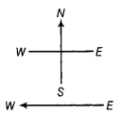 | [1]
38 | How is the strength of the magnetic field at a point near a wire related to the strength of the electric current flowing in the wire? | [1]
39 | Identify the poles of a magnet in the figure. 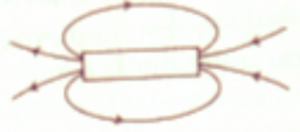 | [1]
40 | Which is the most important safety method used for protecting home appliances from short - circuiting or overloading? | [1]
41 | Why are magnetic field lines closed curves? | [1]
42 | Draw a diagram to show magnetic field due to a bar magnet in a given region. | [1]
43 | What does the degree of closeness of magnetic field lines near the poles signify? | [1]
44 | What do you mean by magnetic field of a magnet? | [1]
45 | What is,  - an electric fuse and  - art electric switch? | [1]
46 | A stationary charge is placed in a magnetic field. Will it experience a force? Give reason to justify your answer. | [1]
47 | What is an electromagnet? | [1]
48 | Define a compass. | [1]
49 | What is the necessity of earthing an electric appliance? | [5]
50 | Write the factors on which the strength of magnetic field produced by a current carrying solenoid depends? | [5]
51 | Describe an experiment of illustrate the action of an electric fuse. | [5]
52 | What is an electromagnet? Upon what factors its strength depends? | [5]
53 | What is the function of safety fuse ? How it connected in circuit ? | [5]
54 | What are essential precautions to be used while using electricity ? | [5]
55 | Describe the activity that shows that a current - carrying conductor experiences a force perpendicular to its length and the external magnetic field. How does Fleming’s left - hand rule help us to find the direction of the force acting on the current - carrying conductor? | [5]
56 | How does a solenoid behave like a magnet? Can you determine north and south poles of current carrying solenoid with the help of bar magnet? Explain. | [5]
57 | - State Fleming’s Left - hand rule.  - List three characteristic features of the electric current used in our homes.  - What is a fuse? Why is it called a safety device?  - Why is it necessary to earth metallic electric appliances? | [5]
58 | - Draw magnetic field lines produced around a current - carrying straight conductor passing through cardboard. Name, state and apply the rule to mark the direction of these field lines.  - How will the strength of the magnetic field change when the point where the magnetic field is to be determined is moved away from the straight wire carrying constant current? Justify your answer. | [5]
59 | With the help of a labeled circuit diagram illustrating the pattern of field lines of the magnetic field around a current - carrying straight long conducting wire. How is the right - hand thumb rule useful to find the direction of the magnetic field associated with a current - carrying conductor? | [5]
60 | Draw an appropriate schematic diagram showing common domestic circuits and discuss the importance of fuse. Why is it that a burnt out fuse should be replaced by another fuse of identical rating? | [5]
61 | What precaution should be taken to avoid the overloading of domestic electric circuit ? | [5]
62 | What is the pattern of magnetic field due to a circular coil carrying current? | [5]
63 | - State Fleming’s left - hand rule.  - Write the function of the following parts of an electric motor.  - Brushes  - Split ring | [5]
64 | - A magnetic compass shows a deflection when placed near a current carrying wire. How will the deflection of the compass get affected if the current in the wire is increased? What does it indicate?  - State Right hand thumb rule. | [5]
65 | - Name and state the rule to find the direction of force experienced by a current - carrying straight conductor placed in a magnetic field which is perpendicular to it.  - Draw a well labelled diagram of an electric motor. | [5]
66 | - Draw the magnetic field lines through and around a single loop of wire carrying electric current.  - State whether an alpha particle will experience any force in a magnetic field, if :  - It is placed in the field at rest.  - It moves in the magnetic field parallel to field lines.  - It moves in the magnetic field perpendicular to field lines.  Justify your answer in each case. | [5]
67 | Explain house hold electric circuits. What are their relative advantages? | [5]
68 | Draw the pattern of magnetic field lines produced around a current carrying straight conductor passing perpendicularly through a horizontal cardboard. State and apply right - hand thumb rule to mark the direction of the field lines. How will the strength of the magnetic field change when the point where magnetic field is to be determined is moved away from the straight conductor? Give reason to justify your answer. | [5]
69 | Study the following current - time graphs from two different sources: 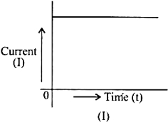  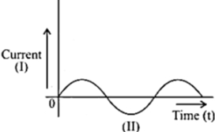  - Use above graphs to list two differences between the current in the two cases.  - Identify one source each for these currents. | [5]
70 | Give magnetic field due to solenoid. On what factors the strength of the field depends? | [5]
71 | What is the pattern of magnetic field pattern due to current carrying conductor. | [5]
 | Section C
72 | Read the following and answer any four questions: An electric current flowing through a conductor produces a magnetic field. The field so produced exerts a force on a magnet placed in the vicinity of the conductor. The magnet must also exert an equal and opposite force on the current - carrying conductor. The direction of the current and that of the magnetic field perpendicular to each other and found that the force is perpendicular to both of them.  - Which of the following devices use current - carrying conductors and magnetic fields?  - electric motor  - electric generator  - loudspeakers  - all of the above  - An electron beam enters a magnetic field at a right angle to it as shown in the figure 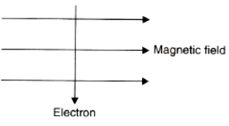  - The direction of force acting on the electron beam will be  - to the right  - to the left  - into the page  - out of the page  - A positively charged particle (alpha - particle) projected towards the west is deflected towards north by a magnetic field. The direction of the magnetic field is  - towards south  - towards east  - downward  - upward  - The electric motor is a device that converts  - mechanical energy to electrical energy  - electrical energy to mechanical energy  - chemical energy to mechanical energy  - mechanical energy to light energy.  - A horizontal wire carries a current as shown in the figure below between magnetic pole N and S: 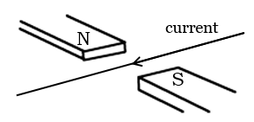  - Is the direction of the force on the wire due to the magnet  - in the direction of the current  - vertically downwards  - opposite to the direction of the current  - vertically upward | [4]
73 | Read the passage and answer any four questions: The magnetic field produced by a current - carrying straight wire depends on the distance. A coil of many circular turns of insulated copper wire wrapped in the circular pattern is a solenoid. Every point of the current - carrying loop gives rise to the magnetic field. A strong magnetic field produced inside a solenoid can be used to magnetize a piece of magnetic material, like soft iron, when placed inside the coil. 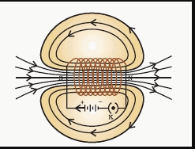  - The magnetic field inside a long straight solenoid carrying current:  - is zero  - decreases as we move towards its end  - increases as we move towards its end  - is the same at all points  - The magnetic effect of current was discovered by :  - Maxwell  - Fleming  - Oersted  - Faraday  - The magnetic field lines in the middle of the current - carrying solenoid are:  - circles  - spirals  - parallel to the axis of the tube  - perpendicular to the axis of the tube  - Which of the following correctly describes the magnetic field near a long straight wire?  - The field consists of straight lines perpendicular to the wire.  - The field consists of straight lines parallel to the wire.  - The field consists of radial lines originating from the wire.  - The field consists of concentric circles centred on the wire.  - The strength of the magnetic field between the poles of an electromagnet would be unchanged if:  - current in the electromagnet winding were doubled  - direction of current in electromagnet winding were reversed  - distance between the poles of electromagnet were doubled  - material of the core of electromagnet were changed | [4]
74 | Read the following and answer any four questions: The compass needle gets deflected when brought near a bar magnet. The magnet exerts its influence in the surrounding region. The magnetic field is a quantity that has both direction and magnitude. Magnetic field lines have various properties. The direction of the magnetic field is taken to be the direction in which a north pole of the compass needle moves inside it. 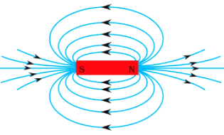  - A strong bar magnet is placed vertically above a horizontal wooden board. The magnetic lines of force will be:  - only in a horizontal plane around the magnet  - only in a vertical plane around the magnet  - in horizontal as well as in vertical planes around the magnet  - in all the planes around the magnet  - The magnetic field lines produced by a bar magnet:  - originate from the south pole and end at its north pole  - originate from the north pole and end at its east pole  - originate from the north pole and end at its south pole  - originate from the south pole and end at its west pole  - The magnetic field lines:  - intersect at right angles to one another  - intersect at an angle of 45° to each other  - do not cross one another  - cross at an angle of 60° to one another  - What is the condition of electromagnetic induction?  - There must be a relative motion between the coil of wire and the galvanometer.  - There must be a relative motion between the galvanometer and a magnet.  - There must be a relative motion between the galvanometer and the generator.  - There must be a relative motion between the coil of wire and a magnet.  - Which of the following statements is incorrect regarding magnetic field lines?  - The direction of the magnetic field at a point is taken to be the direction in which the north pole of a magnetic compass needle points.  - Magnetic field lines are closed curves  - If magnetic field lines are parallel and equidistant, they represent zero - field strength  - The relative strength of the magnetic field is shown by the degree of closeness of the field line | [4]

